

**Oregon City Planning Directors Association**

1201 Court Street NE, Salem, OR 97301 *Ph: (503) 588-6550 ▪ Fax: (503) 399-4863*

**Board Agenda**

**Wednesday, September 25, 2019**

**10:00 a.m. (PST)**

**Riverhouse on the Deschutes, Deschutes Room**

**Bend, OR (See Map Attached)**

*If you are unable to attend in person, join the meeting by calling: 1-800-504-8071*

*PIN: 8410998#*

1. Call to Order
2. Roll Call
3. Approval of Minutes
4. Election Results
5. Legislative Update
6. Membership Drive Update
7. Future Meetings
8. LOC Affiliate Contracting Discussion
9. Other Business
10. Adjourn

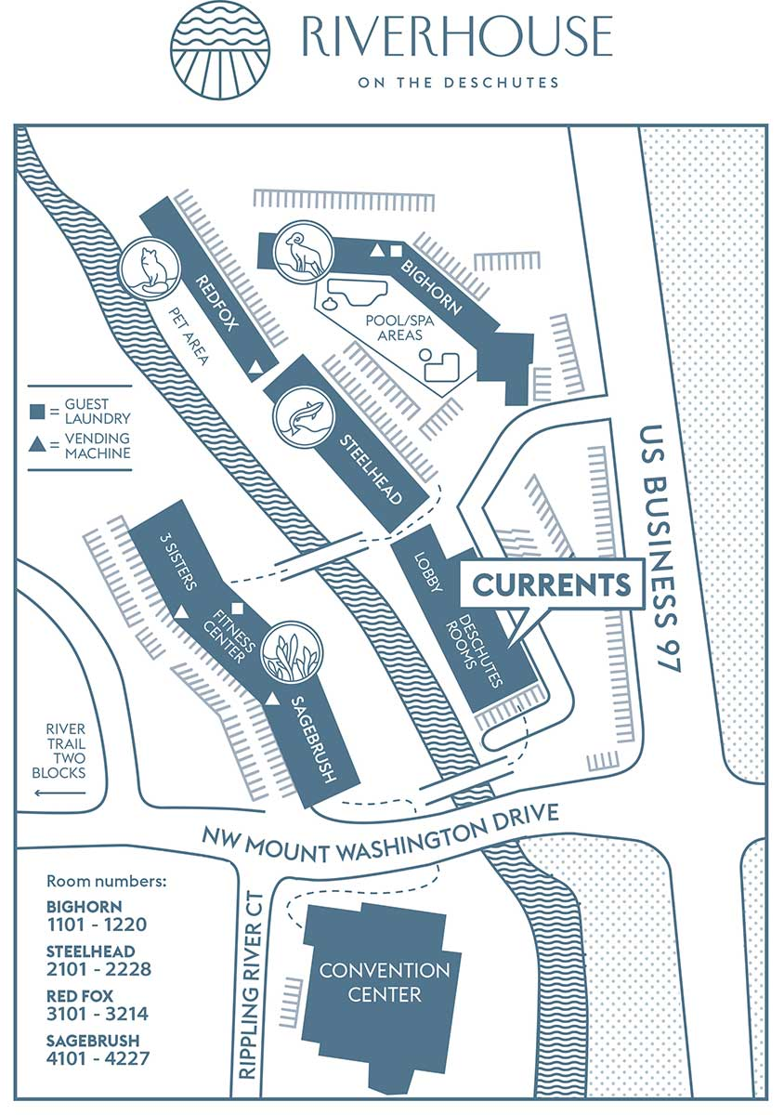

**OCPDA Board Meeting**